

**Northern Illinois University**

**OMIS 643– Enterprise Process Improvement**

**(Spring – 2017)**

**Assignment 1**

**Mapping Business Processes**

**By-**

**Vivekraj Yuvaraj (Z1806698)**

**Neha Farya (Z1808969)**

1. **Relationship Map:**

**C:\Users\Neha Farya\Downloads\Relationshipmapfinal0213.png**

1. **Cross Functional Flow Chart:**

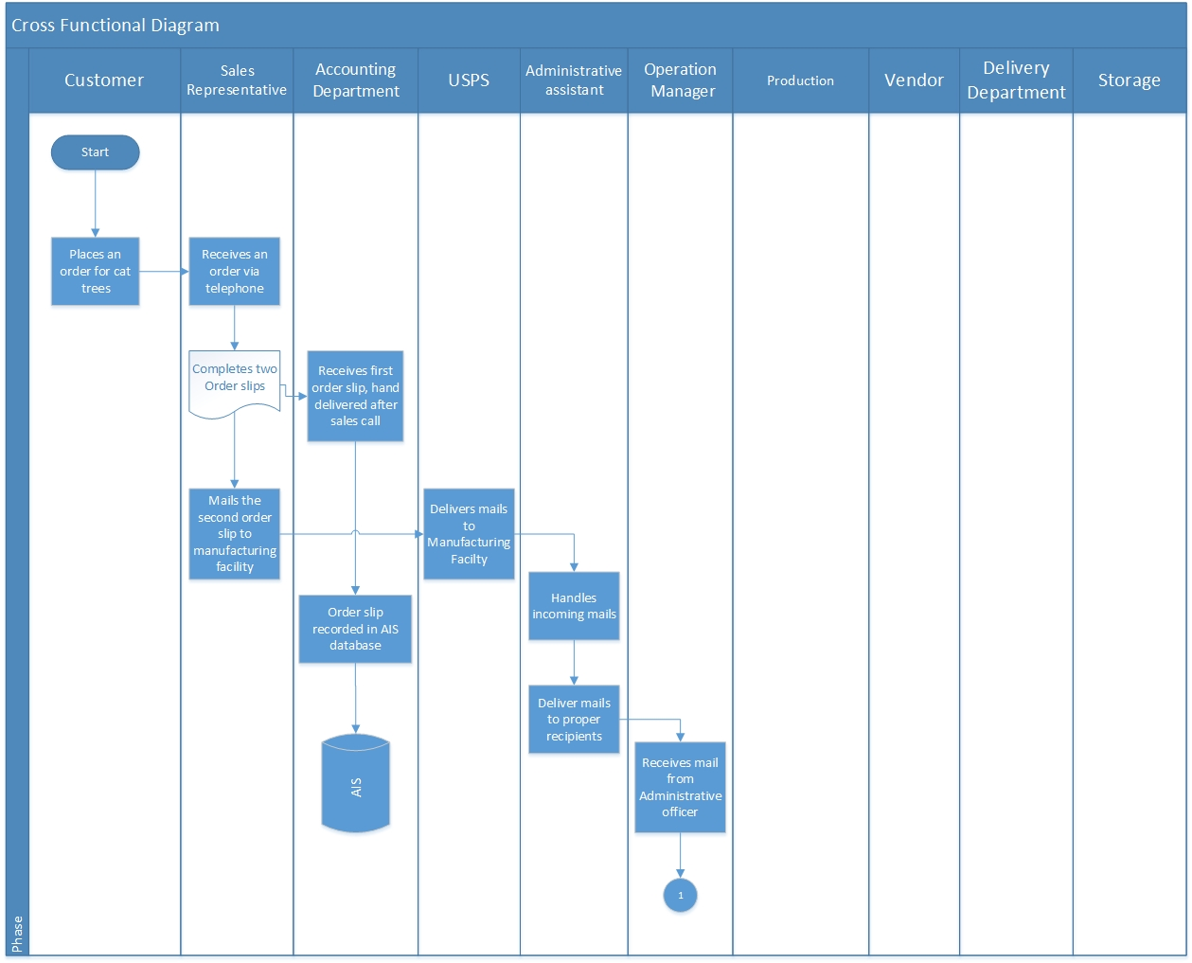

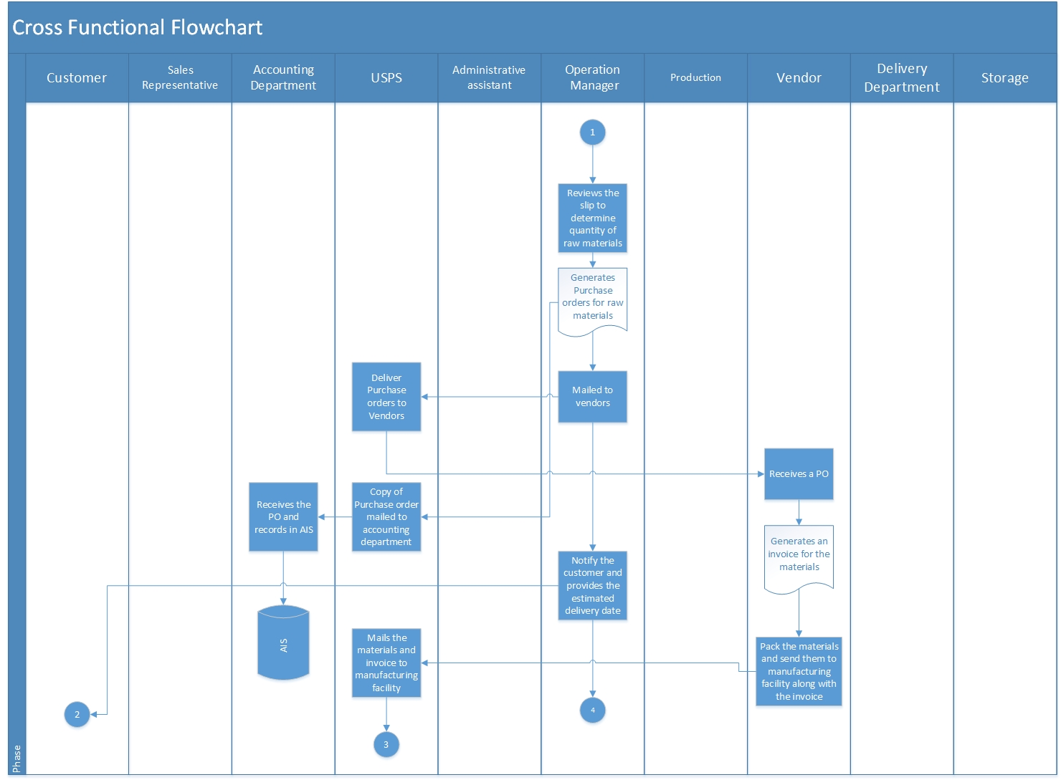

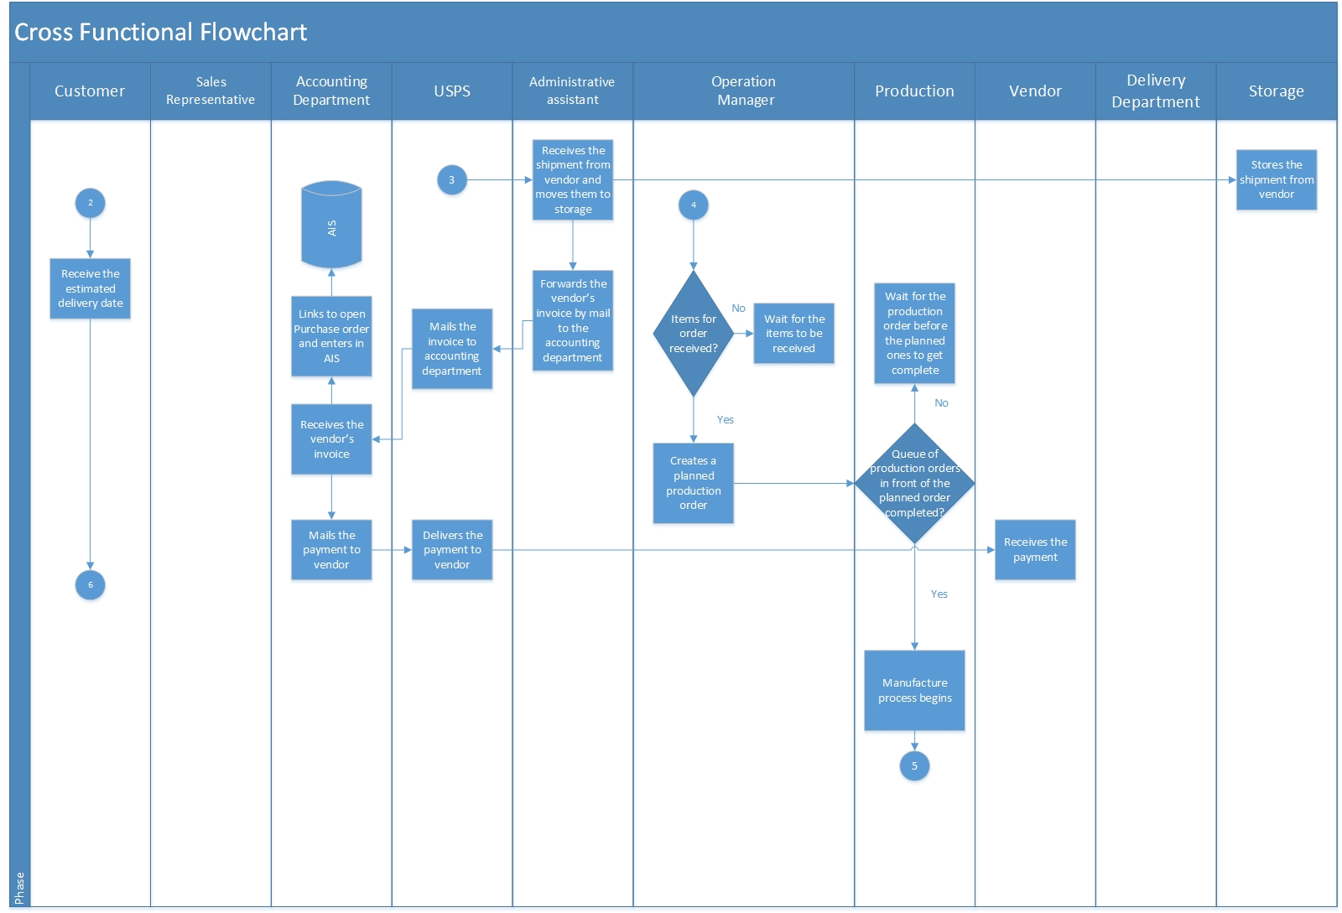

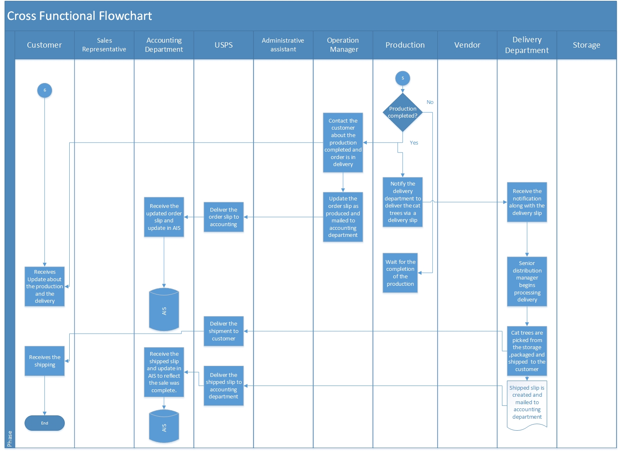 **3. Cycle Time and Value Analysis:**

|  |  |  |  |  |  |  |  |  |
| --- | --- | --- | --- | --- | --- | --- | --- | --- |
| **Sequence** | **Activity** | **To** | **Tm** | **Tp** | **Time in days** | **Real Value** | **No Value** | **Business Value** |
| 1 | Mailing second order slip to accounting department through US postal services | 2 | 3 | 5 | 3.17 |  | X |  |
| 2* | Feeding Order information to AIS |  |  |  | 0.00 |  |  | X |
| 3 | Administrative assistant forwards order mail to proper recipients | 2 | 3 | 5 | 3.17 |  |  | X |
| 4 | Purchase order creation process by operation manager | 1 | 2 | 2 | 1.83 |  |  | X |
| 5 | Mailing completed PO to vendor | 2 | 3 | 5 | 3.17 |  | X |  |
| 6* | Mailing PO to accounting department | 2 | 3 | 5 | 3.17 |  | X |  |
| 7 | Feeding PO information in to AIS |  |  |  | 0.00 |  |  |  |
| 8 | Vendor sending packed raw materials to Setterstrom co.’s | 7 | 8 | 10 | 8.17 |  |  | X |
| 9* | Moving raw materials to storage |  |  |  | 1.00 |  |  | X |
| 10 | Forwarding vendor invoice to accounting department by mail | 2 | 3 | 5 | 3.17 |  | X |  |
| 11* | Linking vendor invoice to the open PO in AIS |  |  |  | 0.00 |  |  | X |
| 12* | Accounting Department mailing payment to the vendor | 2 | 3 | 5 | 3.17 |  | X |  |
| 13 | Manufacturing process of the order | 7 | 7 | 14 | 8.17 | X |  |  |
| 14 | Entire production process | 3 | 3 | 5 | 3.33 | X |  |  |
| 15 | Mailing accounting department indicating "produced" | 2 | 3 | 5 | 3.17 |  | X |  |
| 16 | Order slip is updated in AIS indicating "produced" |  |  |  | 0.00 |  |  | X |
| 17 | Processing delivery by senior distribution manager | 3 | 5 | 5 | 4.67 |  |  | X |
| 18 | Picking and packing processes |  |  |  | 2.00 | X |  |  |
| 19* | Shipping | 1 | 2 | 2 | 1.83 | X |  |  |
| 20 | Mailing shipped slips to corporate office plus waiting time till Monday |  |  |  | 7.00 |  | X |  |

Total cycle time: **51 days**

*Sequence 1 is in parallel with subsequent sequence 2 and 5 is in parallel with 6. Similarly, sequence 10 is in parallel with 9, 11, 12 .19 is in parallel with 20 , hence we are eliminating the time taken by those activities.

**4. Efficiency of the current business process:**

After analysing the current business process of Setterstrom Company, there are couple of inefficient business processes and they are listed below:-

1. The time taken to receive and review the order slip by the operation manager and generation of the purchase order contribute most in delaying the process which is around 8 days(2 days to deliver from administration officer, 3 days to deliver via USPS,1 day to review and 2 day for generation of PO) .
2. The time taken to process the delivery, picking up the cat tress from the shelves , packaging and shipping by the senior distribution manager where the it takes around 8 days(5 days to go through that slip,2 days for processing,1 day for shipping)

**What cannot be improved by the current business process?**

Though it takes 3.16 days for USPS to deliver mails, it cannot be controlled by Setterstrom company’s business process. Similarly, the order processing by raw material vendor cannot be controlled.

**What could be improved?**

1. The generation of the purchase order can be made efficient to 1 day as when the sales representative receives the order from the customer, he can call the operation manager right away, about the raw materials needed and the operation manager can issue the PO right away after the call.

2. As soon as the delivery receipt is received by the senior distribution manager, he should have given it to the junior distribution employees right away to process, pick the cat trees, pack them and ship them. So the whole time of packaging and delivery is reduced to 3 days.

**5. Improvement in business processes:**

The following steps we have taken to improve the business processes by reducing the cycle time:

1. We have implemented an efficient information system such as ERP, which can help in reengineering the current business process resulting in efficient delivery of cat trees.

2. We have implemented Setterstrom’s Company Website to receive the orders of the cat trees from the customer and record the same in the information system, replacing the role of the sales representative and letting the customers to make payment right away after placing the order. Also, the website provides customers with detailed information about the cat trees and the confirmation mail of the order.

3. Since, the order is placed almost instantly, with online payment options customers can choose to pay via eCheck, credit/debit card, etc. The payment details are stored in the Setterstrom’s information system of ERP.

4. We have integrated the web Application with Setterstrom’s ERP, so all the orders placed by customers are redirected to the ERP SCM system and where customer can track their order details in real time.

5. We have also implemented the new system with the storage/inventory with increased capacity where we will store the raw materials needed for the cat trees .So, the manufacturing process begins right after they receive an order. If the stock is not available PO will be created and sent to vendor to receive raw materials.

6. The employees in the packing department can view the status of the production and can begin the packaging and processing of the orders and send for shipping via shipping firm.

7. Following the shipment process, customers receive their respective orders.

1. **Cross functional flow chart for improved business processes:**

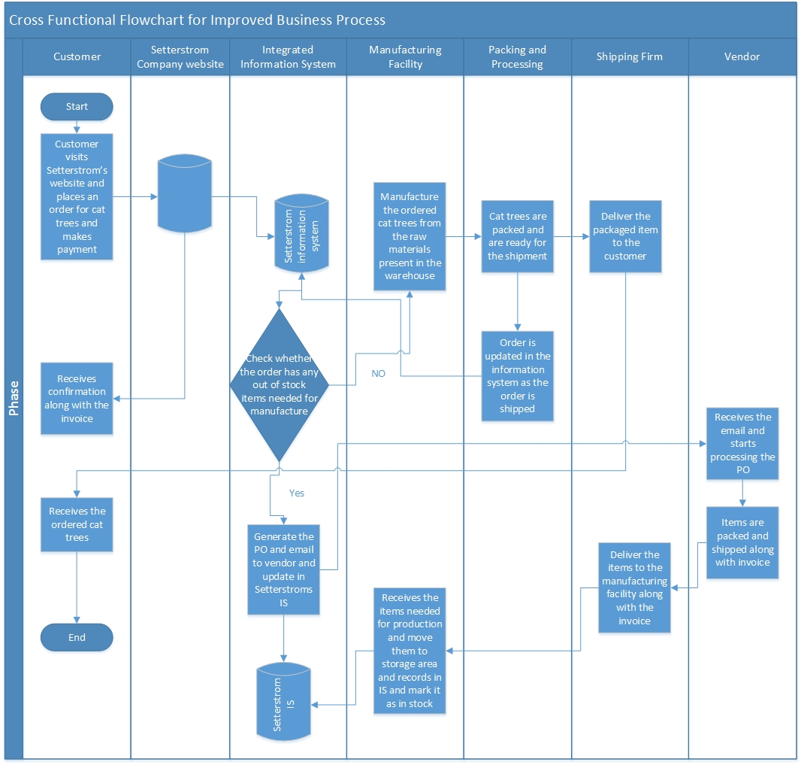

**b. The new cycle time:**

|  |  |  |  |  |  |
| --- | --- | --- | --- | --- | --- |
| **When Raw Materials are available in storage** | | | | | |
| **Sequence** | **Activity** | **Time in days** | **Real Value** | **No Value** | **Business Value** |
| 1 | Receiving the order at the manufacturing facility and begins production | 8 | X |  |  |
| 2 | Entire production process | 3 | X |  |  |
| 3 | Picking and packing processes | 2 |  |  | X |
| 4 | Shipping | 2 | X |  |  |

**Total Cycle time after improved business processes**: 15 days

|  |  |  |  |  |  |
| --- | --- | --- | --- | --- | --- |
| **When Raw Materials not available in storage** | | | | | |
| **Sequence** | **Activity** | **Time in days** | **Real Value** | **No Value** | **Business Value** |
| 1 | Vendor sending packed raw materials to setterstrom co's | 8 |  |  | X |
| 2 | Receiving the order at the manufacturing facility and begins production | 8 | X |  |  |
| 3 | Entire production process | 3 | X |  |  |
| 4 | Picking and packing processes | 2 |  |  | X |
| 4 | Shipping | 2 | X |  |  |

**Total Cycle time after improved business processes (when items are out of stock)**: 23 days